PRG200 Week 4 Assignment :Programs in Python

Jessica Gurung
Westcliff University
Professor Prakash
PRG200 Programming in Cloud
June 1 , 2026

Question 1 : Small Shop Billing and Inventory System
This program is a mock-up of a grocery store bill system. It keeps a dictionary of prices of items and stock of items. When customers buy stuff, the program will know if there is enough stock, it will calculate the total bill, modify stock and show the remaining stock after the sale.
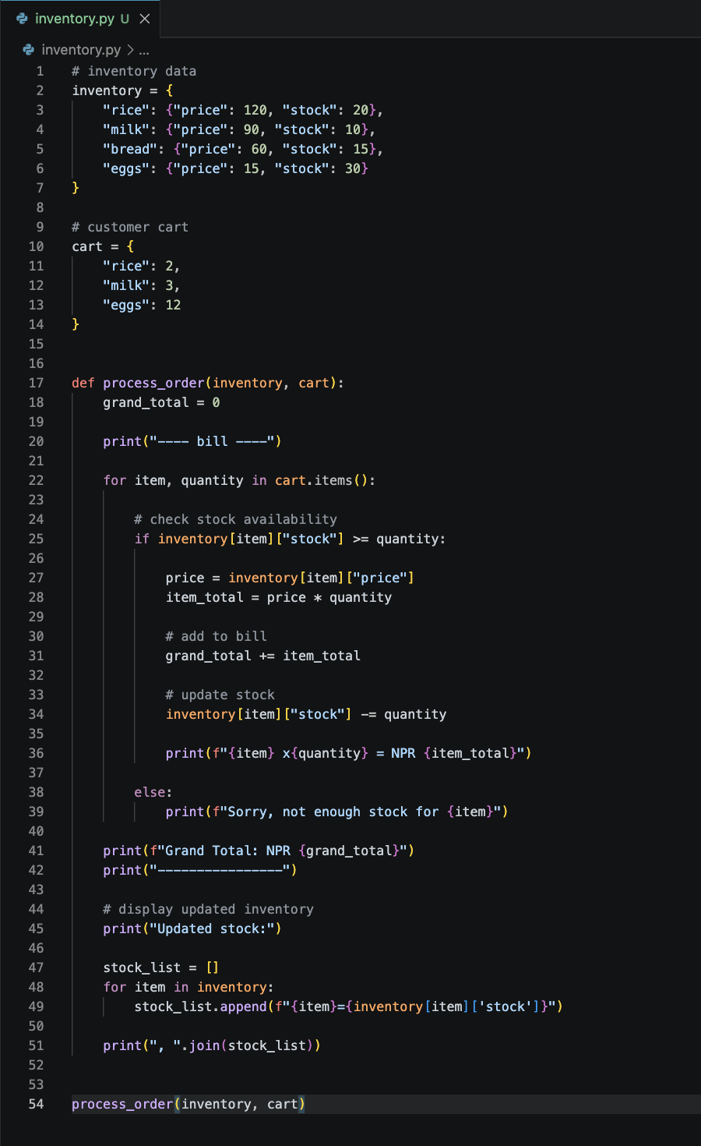
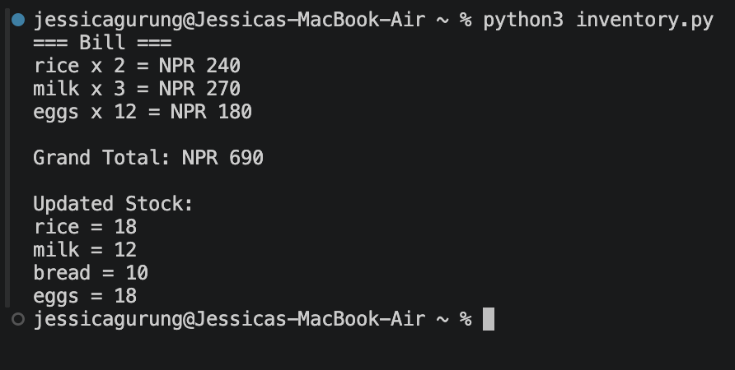

Question 2 : Water Level Alert System:Water Level Alert System:
This program is for the monitoring of water levels from various river sensors. It applies conditional statements to define each reading as either Safe, Warning, or Danger as a result of thresholds that have been set. The program is used to determine where flooding may be possible and to give the appropriate warnings.
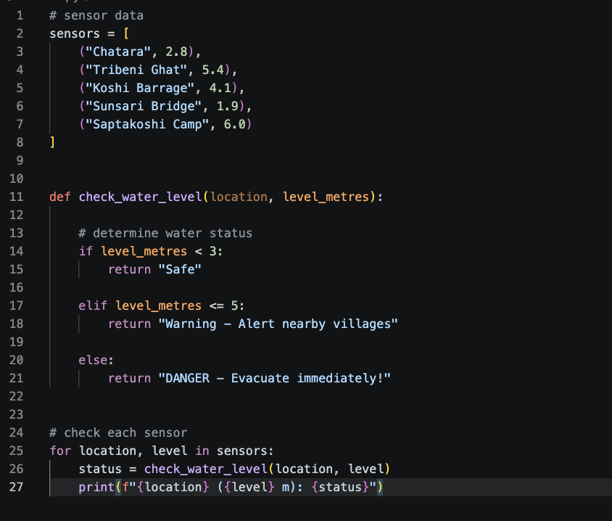
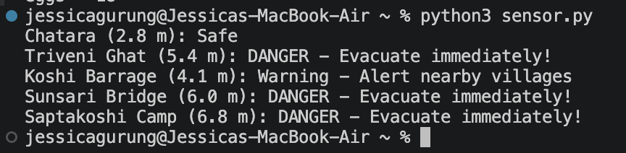

Question 3 : Date Converter for Nepal Bank System
This program is designed to convert a data from AD to BS calender and vice versa . It gets information on year, month and day from a date string , modifies the year based on the conversion type, and returns the converted data in the specific format.
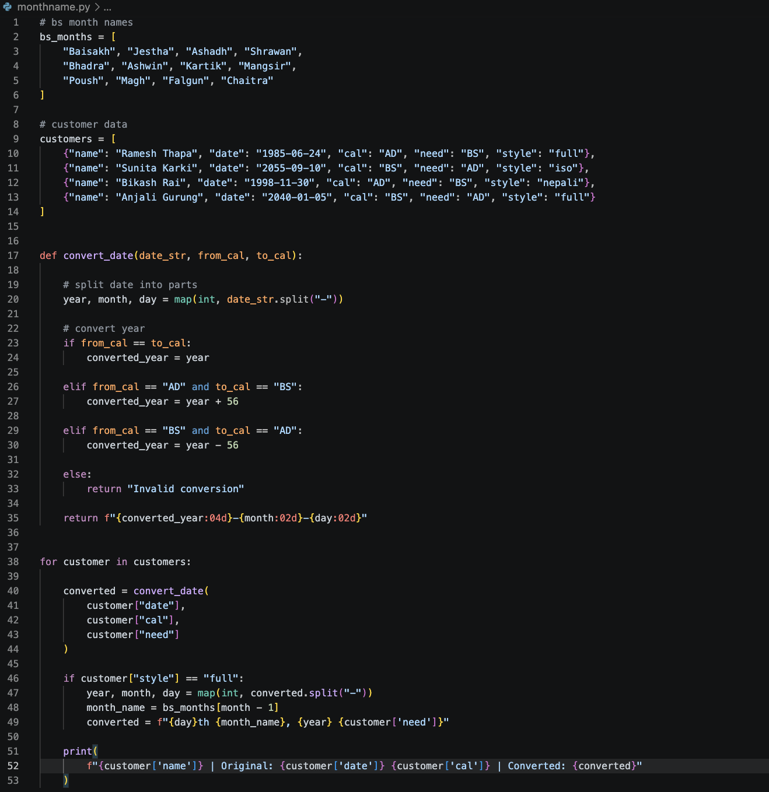
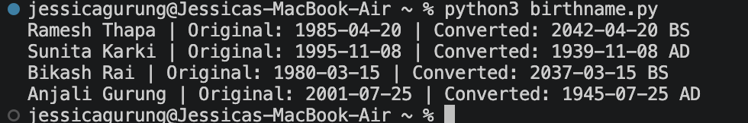

Question 4 : Word Frequency Counter
This program reads a blocks of text and counts the occurrences of each word . It reads every word and pushes it to lower case, removes punctuation , builds a dictionary of word frequencies , and prints the top 3 word frequencies in the text .
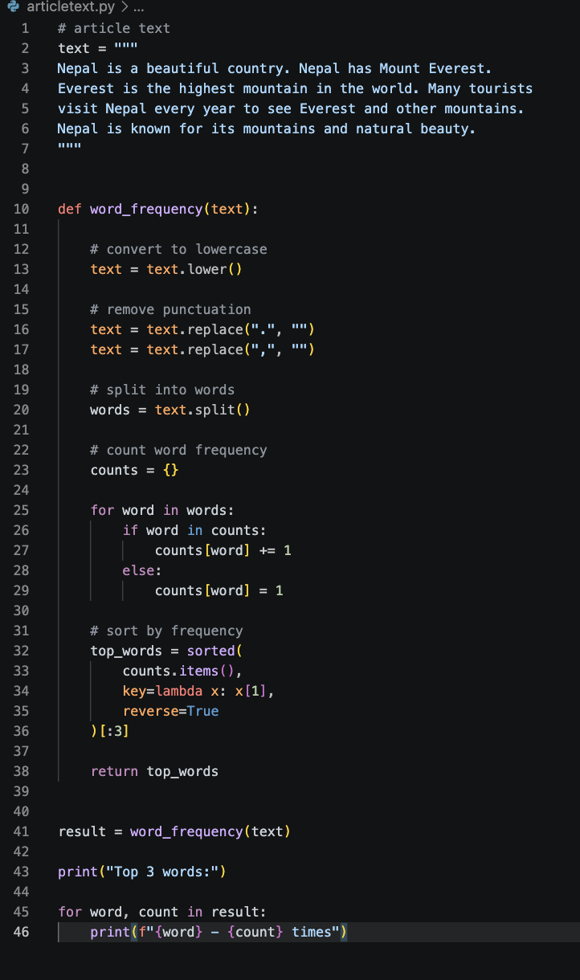

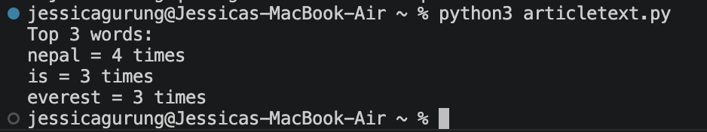

Question 5 : Simple ATM Simulator
This program is a simulation of the basic operation of an ATM . It verifies account numbers and pin numbers, enables the user to check account balance , deposit money and cash out . The program resolves issues like false account , wrong pins and low balance , providing secure transactions.

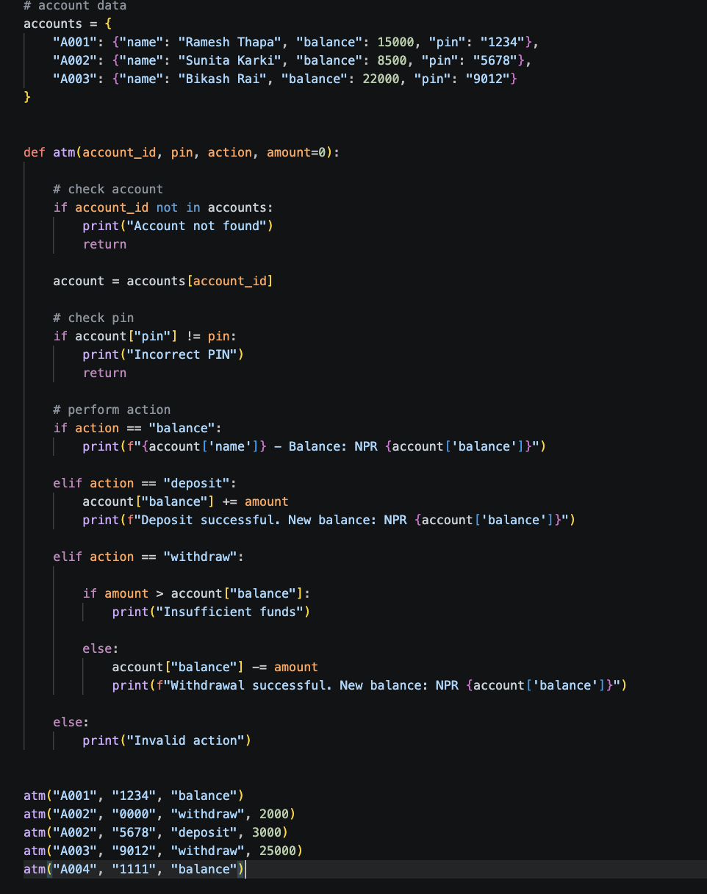
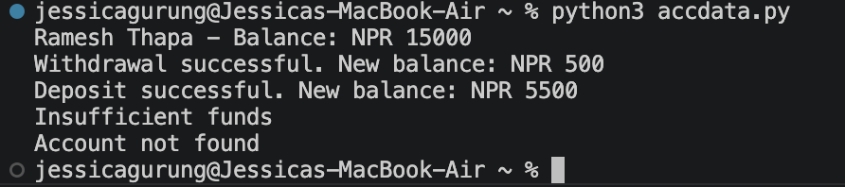
References :
Python Software Foundation. (2025). Built-in types, dict. Python Documentation.
https://docs.python.org/3/library/stdtypes.html
Python Software Foundation. (2025). String methods. Python Documentation.
https://docs.python.org/3/library/string.html

